Vitreous Image Sorting Program

v. 1.0 prepared by Jeff Ketterling (11/24/2014)

Purpose

The program “VitreousScreen.exe” is used for image stacks acquired from a Quantel Aviso unit. The \*.raw file cineloop from the Aviso will contain 100 images in an envelope detected, log-compressed, U8 bit format. Some of the images may contain multiple echo or other artifacts and these images needed to be logged in order to avoid processing them. The screening process just requires someone to quickly run through the image stack and push a button each time a good image is seen. A text file is created in the folder with the raw data. This file has the numbers of the good image frames.

Initial Setup

The program “VitreousScreen.exe” requires the installation of a LabVIEW run-time engine from National Instruments. This software is named “LabVIEW Run-Time Engine 2014” for Windows. Mac OS is not supported for the \*.exe. The installer will be on the Riverside FTP site. It is about 260 MB.

The installer can also be downloaded at - http://www.ni.com/download/labview-run-time-engine-2014/4887/en/

Run the installer and follow prompts.

The actual screening software is in a zip file called Run-Time Vitreous. This was sent as an attachment and a copy is also on the Riverside FTP site. Unzip and move the files to a folder on the PC. The location of files on the PC is not important.

Using Software

1. Double click VitreousScreen.exe. A file dialogue will open if no file was already specified. This will open a run-time window.

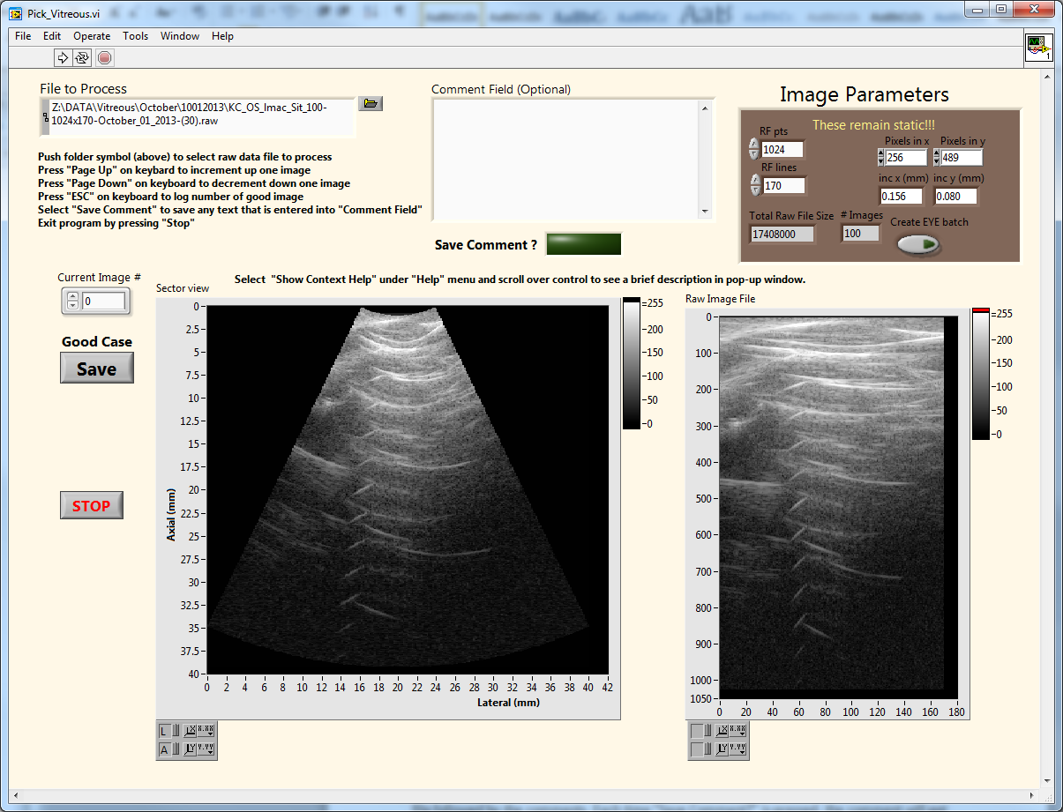

2. Pressing “Page Up” will increment the image and “Page Down” down will decrement the image. Holding the keyboard buttons down will result in a rapid animation sequence as the images are scrolled through.

3. For each \*.raw stack, we want to log which images are free of artifacts such as multiple echoes or incorrect scan plan. This is down by pressing “Esc” on the keyboard for each good image, starting at image 0. The image stack can be rapidly screened via keyboard inputs of “Page Up” followed by “Esc”. It is not a problem if an image is logged multiple times by accident.

A text file will be created that has the same name as the \*.raw file but it will end with the .txt extension. The file will be in the same folder as the \*.raw file.

4. To process a new \*.raw file, simply click the folder symbol and a file dialogue will open.

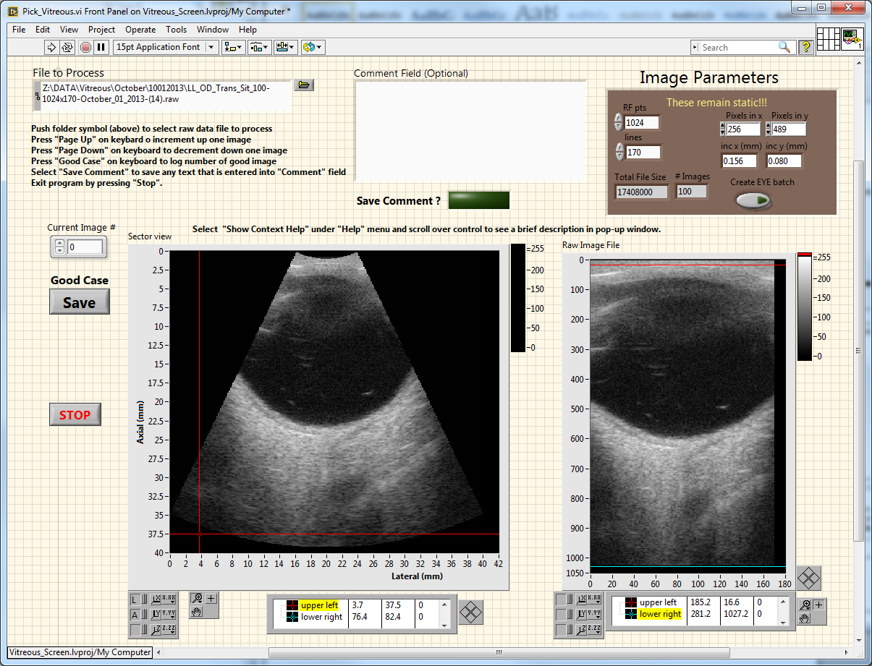

5. If there is something unusual about the case, a comment file can be saved. This is done by entering text into the Comment field and then pressing “Save Comment?”

A .txt file is created in the same folder as the \*.raw file. The file will have the name of the \*.raw file followed by the comments. Each time “Save Comment?” is pressed, the comment will get appended to the existing notes file.



6. The program can be stopped by pressing the “Stop” button.



7. A stopped program can be started again by pressing the arrow pointing to the right.



8. A help window explain each control or display can be access by selecting “Show context help”.

